Oregon’s Visualization Laboratory

Background and Vision:
Designed as a comprehensive and centralized facility serving all the scientific and related disciplines, Oregon’s Visualization Laboratory (OrVL) provides extensive systems and support for research computing using advanced visualization tools, simulation protocols, programming resources and display options. OrVL (pronounced Orville), is a collaboration of Information Services, the University of Oregon Libraries and Media Services, Computer and Information Sciences, and researchers from data-intensive disciplines. OrVL represents an integration of computational science, networking, visualization, and related cyber-infrastructure services including data storage, retrieval, and preservation.
Visualization of complex data sets is now the major requirement for advances in geosciences, life and physical sciences. While many smaller-scale visualization labs have been created across the broader research community to serve specific areas such as engineering and medicine, the University of Oregon is in a unique position to create a large scale lab designed to support our strengths in basic scientific research and to foster future collaborations among the science departments, institutes, and professional schools. OrVL will allow researchers to build large-scale simulations and manipulate and display vast quantities of data for the purposes or creating and testing hypotheses, predicting outcomes, expanding our understanding of complex problems, and contributing to real-world solutions. OrVL will have an immediate impact on the geosciences, neuroscience, nanotechnology and material science, human physiology, physics and astrophysics, anthropology, and microbiology as well as social sciences that make extensive use of geospatial, demographic or other numeric data. OrVL will provide a venue for the disciplines to work together and to combine data from various research efforts and see the impact of different variables on complex scenarios. In turn, such a facility will escalate our teaching at both the graduate and undergraduate level and will serve as significant centerpiece for engaging undergraduates in real world research projects and computational thinking. OrVL should help to attract graduate students in several disciplines and provide new opportunities for GTFs.
Many fields of science are currently overwhelmed by the sheer volume of observational and experimental data that define them. As a result, current limitations in the rate and ability to process, analyze and display data are slowing the progress in our conceptual understanding of various aspects of the natural world at a time when we can least afford a slow down. Also, the funding agencies, led by the NSF, are requiring more substantive plans for the curation of data and its interoperability. For those reasons, OrVL will be built to address many of the infrastructure issues related to the data preservation and usability. By focusing on a large-scale centralized facility (as opposed to several smaller specialized facilities) the University will be able to create a strong team of expertise to provide the full range of services associated with a multi-purpose visualization facility.

Examples:
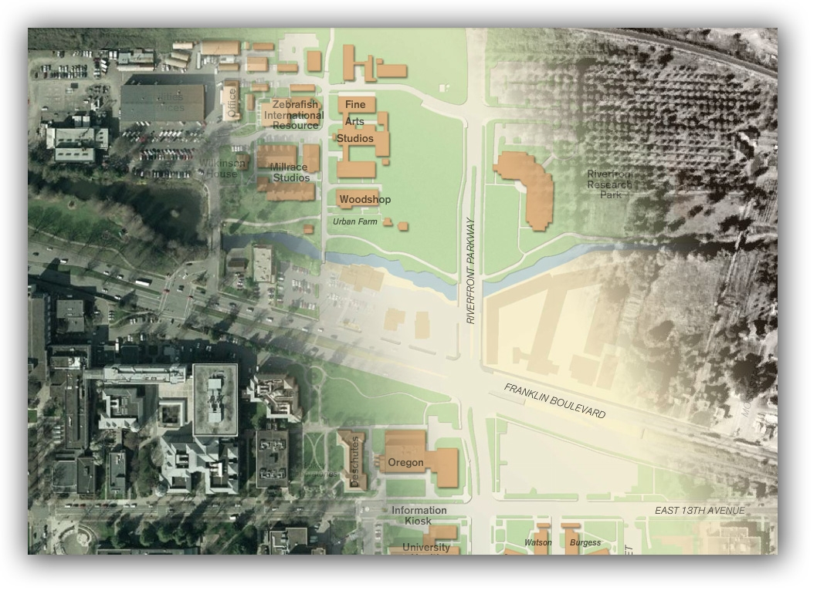
Advanced GIS Representation: Geographic information systems and remote sensing have revolutionized the collection and analysis of field data in the earth and ecological sciences. High-resolution measurements of land surface phenonema are increasingly done with remote sensing, and these data are analyzed with other data types in spatial views. OrVL will allow the display of multiple layers of information at high resolution, with extensive zooming capacity and 3-D viewing. Combining visualizations of data on the environment with data on populations, land use and socioeconomic variables is a powerful new approach in social science research as well as policy decision-making.
Experimentation, Research, and Teaching : OrVL will serve as research and testing facility for faculty in CIS who are helping to develop new tools. In addition to this research function, the facility will be showcase for emerging technologies and allow faculty to experiment with the latest visualization tools and applications. OrVL will also be designed as a teaching facility, allowing students to take advantage of many of the interactive features. Staff will work closely with faculty to help prepare visualizations for both for research and teaching. The teaching facility potentially could be used in classes from biology, sociology, history, or many other disciplines with large multimodal data sets (numerical, text, graphic, geospatial), to expose even lower division discussion sections to the power of visualization.

Content Integration and Interactive Mapping. The lab will provide the tools and display options to integrate geovisualization with other types of information, e.g. text, photos. It will also serve as a laboratory for extending the capabilities of interactive mapping. The InfoGraphics Lab is already a leader in this area, with current projects on dynamic interactive mapping for urban studies and architecture, archaeology, and transportation/movement. OrVL facilities will increase their national stature in this field. Interactive mapping has potential applications in many other professional, science and social science fields.

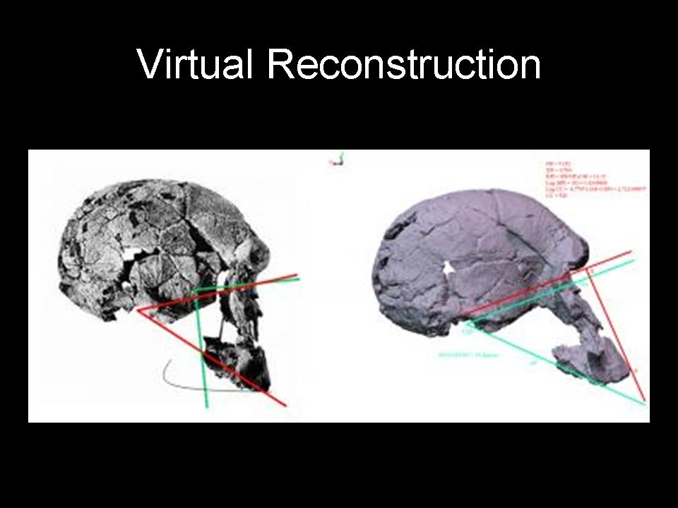
Evolutionary Theory. Anthropologists and paleontologists study visual comparisons to understand human behavior as well as human evolution and primate lineages. OrVL will provide the capacity to capture 3D surface models, conduct virtually reconstructing, or "retrodeforming" of fossil specimens, and estimating morphology for the last common ancestor of different species using various models for morphological change. An emerging technology that will enhance both research and teaching in these areas is 3-D printing.

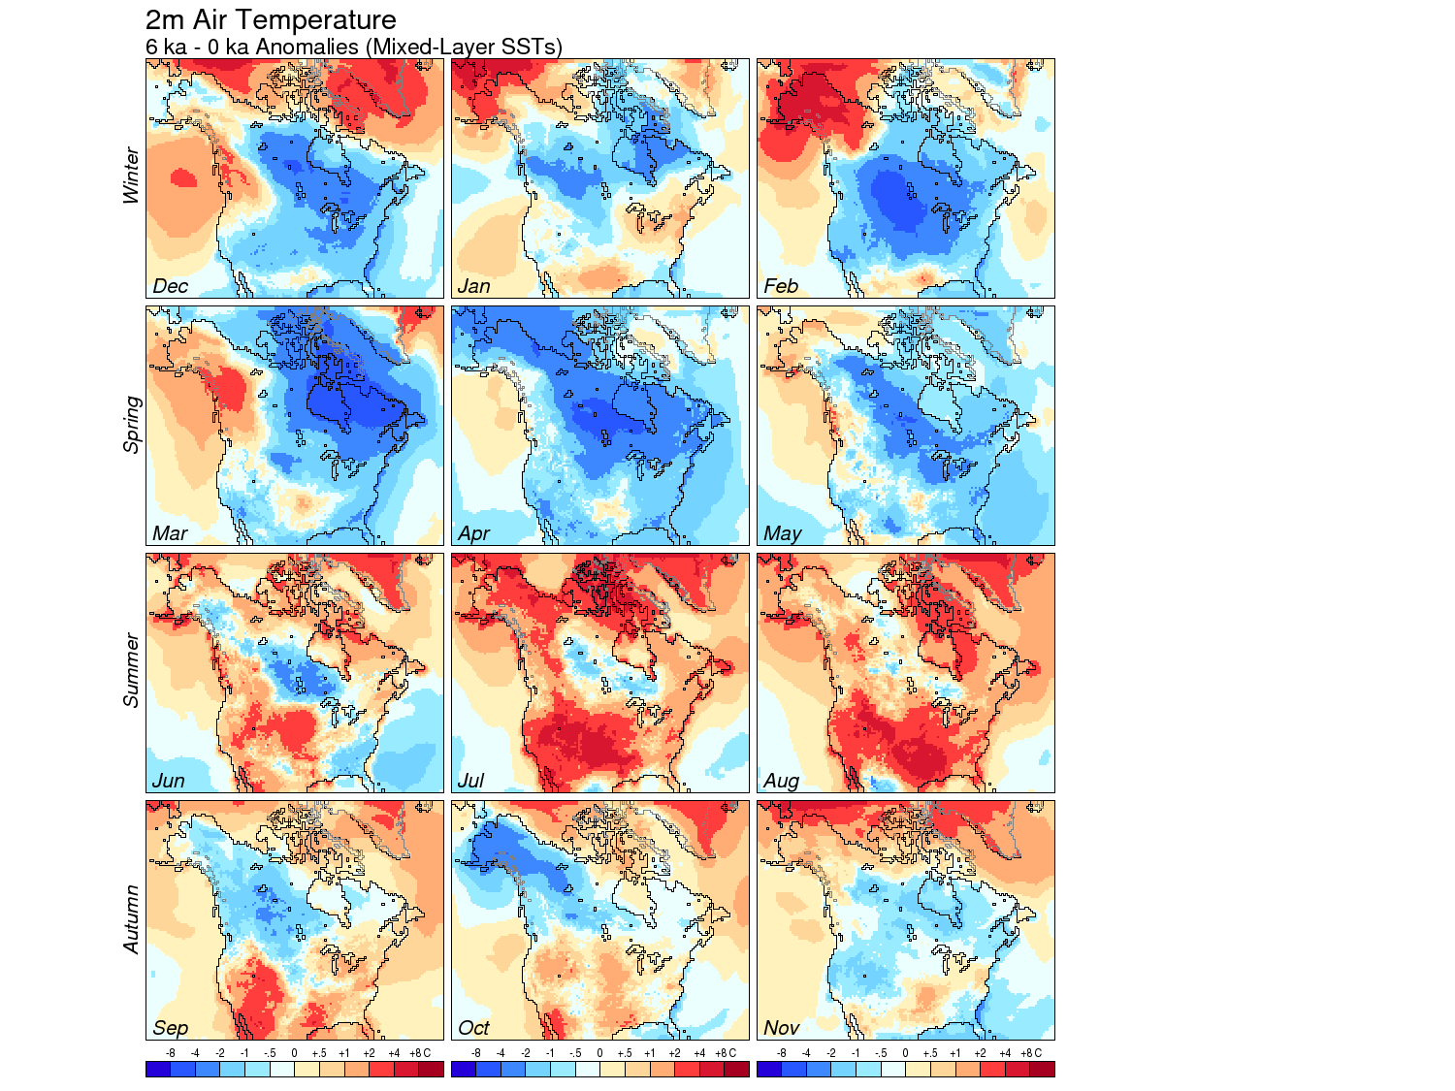

Climate Modeling and Display: OrVL will allow researchers to view high spatial and temporal resolution images related to climate change and other types of environmental modeling. Researchers will be able to work with large geospatial data sets produced from satellite remote sensing and by earth-system models, and to overlay and manipulate multiple variables, including climate variables such as temperature, atmospheric pressure, net radiation, wind speed and direction, and variables that describe other Earth-system components, such as wildfires, vegetation, soil moisture, etc. Visualization is the key technique for using these spatially extensive, multi-variable, data sets to understand the controls of climate variability and the impacts of climate change. The advanced visualization tools of OrVL will enable new advances in this field by UO researchers.

Carbon Nanotube Networks: These networks have widespread application in many areas of biomedicine (as in detection mutation in DNA by measuring the change in electrical properties of the nanotube as the DNA molecule sticks to its surface), hydrogen storage, electron transport and quantum computing. Breakthroughs in this promising technology require advanced visualization and simulation of literally millions of individual carbon nanotubes all meshed and interconnected in a common network.

Earth Surface Processes – An important research area within the Earth Sciences involves processes that alter the Earth’s surface, through processes such as landslides, floods, earthquakes, and volcanic eruptions. New ways of imaging the surface, such as LiDAR (Light Detection And Ranging), provide exciting opportunities to analyze these processes in new ways but require analysis and manipulation of very large data sets and would benefit by improved means of visualization.

Functions and Specifications:

The major functions of OrVL include domain science research using visualization tools, research in visualization processes, teaching, cyberinfrastructure services (data acquisition, data storage, data management data integration, and outreach) e.g. for public and media demonstrations.

The design of visualization labs and decision theatres is evolving rapidly. The detailed specifications for OrVL should take advantage of the latest technology and design features, and address the current and developing research activities on this campus. Based on existing research interests and projecting forward to include possible uses of a state-of-the-art facility three to four years from now, some of the basic elements of OrVL should include:

- Teaching space/visualization theatre (25 people)
- Office space for support team
- Rear projection capabilities/space
- Experimental space (for assembling and testing hardware)
- Computer room, control room

- High resolution displays
- Visualization software to support various disciplines
- Advanced interactive displays, e.g. smartboard technology.
- Multi-screen, immersive, 3-D environment
- Large-scale high resolution printing and scanning
- High-performance computing cluster

