Capturing Place:
A Comparison of Site Recording Methods
Nancy Yen-wen Cheng
University of Oregon
Key words: Fieldwork in Architectural Practice, Design Process, Computer Media
Abstract: When designers document locations for site-specific projects, how do tools affect recording of visual data? We observed design students visiting future project locations with sketchbooks, cameras and video and analysed the resulting Web-based field reports by tallying images according to scale and content. The study describes how tools shape place-recording phases and explains how field reports can contribute to understanding the tools. Examining reports from different classes exposed the importance of objectives and setting characteristics in shaping data collection. A refined approach for studying new place-recording tools is suggested.

INTRODUCTION: tools for perceiving places
As experiences of natural and urban environments are displaced by technology-mediated experiences, our need to savour and capture authentic moments increases. After sitting in front of a computer screen all day, even a walk through a parking lot is flooded with stimulating kinaesthesia and evocative sensations. Capturing the sensuous experience of place into a tangible form is a challenge made more enticing by new gadgetry. How can we go to a place and fully convey its essence to someone who is not there?
Since this impulse to document place lies with journalists, geographers, urbanists and artists of all types (Hiss, 1990), it is important to distinguish the needs of the environmental designer. Corner (1992) explains that the challenge of representing environments starts from the size, complexity and richness of the physical world and our limited capacity to record, absorb and process the flood of information. We are further challenged by our tendency to reduce the full sensory experience into visual representation.
While each person will approach a place slightly differently depending on what is sought, there are archetypal objectives that shape what will be captured. For example, a tourist looks for beautiful, famous or unusual photo opportunities. An engineer seeks relevant clues about building performance. A real-estate agent searches a property for marketable labels. A designer’s interest lies somewhere on the continuum between technical assessment and artistic study, since both quantitative facts and qualitative impressions are sought.
By visiting a site, a designer collects information about physical, social and cultural conditions while perceiving nuances that may shape design direction. Ideally, methods of place recording heighten perceptions and strengthen understanding of a location. But as less efficient processes like sketching give way to a new array of techniques, how can we maintain or enhance the thinking eye? Tools such as video cameras, 3D digitisers, and motion-capture devices automate ways to capture a large amount of information efficiently, but do not guarantee a thoughtful process. Since technology influences how we see, it also shapes what we see and how we think. We need to better understand tool biases so we can target their use in situations where they could increase awareness.
To start understanding the influence of tools on the process of recording environments, this study compares traditional sketching and digital photography. After preliminary observations of the process and how it varies with tool usage, we analysed site information distilled onto Web pages by looking at what information can be gleaned from tallying imagery. Preliminary correlations between tool use and content are described along with limitations of the results, and suggestions for further study.
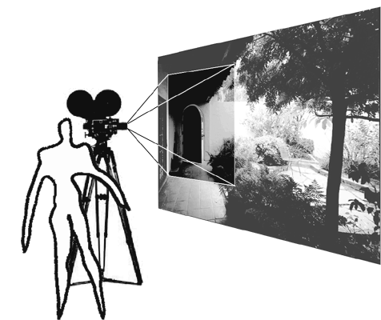
Figure 1. Place recording needs to consider man, media and environment

Rationale for the study
While we can observe qualitative differences in site recording with different tools, it is difficult to track operations and correlate them to thinking. Rather than examining a few designers’ process, this study surveyed a greater number of designers’ products. While interviews or talk-aloud procedures could give a better understanding of the connection between media process and thinking, they were likely to reveal individual idiosyncrasies.
Instead, site information as published on the Web was examined. Because of its accessibility, if it proved useful others could easily and efficiently peruse many cases. As material selected for further study, the Web pages have a special significance in the site-recording process. Even if the images were chosen with little intention, they acquire importance as a substitute for the site in the subsequent design process. Like an amulet or religious icon, the images hanging over a workspace or posted on one’s homepage gain significance after repeated viewings. (Downing 2000) For these reasons, examining the presentation images for ideas on media bias was worth a try.

BACKGROUND:

Phases of site recording
Gathering and presenting place information takes place in the beginning of the design process continuum according to Crowe and Laseau (1984). It makes up part of the Recording and Analysis phases that precede Design. Site recording usually contains some form of 1) Pre-trip preparation, 2) On-site documentation, 3) Post-trip Analysis, 4) Presentation, 5) Reflective use in Design.
Prior to the trip, a designer needs to plan what information will be gathered, how the site will be toured and how team members will be deployed. Equipment and existing documentation needs to be gathered and reviewed so that precious time at the site is used efficiently.
A designer comes to the site with intentions and expectations that may need to be modified at the site. Unfamiliar terrain makes it impossible to fully predict what will be worth recording, so a designer needs an alert eye to catch the unexpected. (Crowe and Laseau, 1984) Particularly for group efforts, a method for organizing and storing ideas, images and video clips is needed. Information needs to be organised in a retrievable form with enough identification & cross-referencing to be useful. Data can be arranged by format, narrative sequence or location so that it feeds naturally into a planned presentation. (Ehrhardt and Gross, 2000)
On returning from the site, the information’s completeness should be reviewed to determine the need for further site visits. The information may be collated like a jigsaw puzzle, or interpreted into diagrams so that patterns can be seen from the fragments. By analysing highlights and deficiencies, design opportunities can be identified.
The results can be presented simply, as in pinned-up photos, or elaborately, as in interactive multimedia websites. Expandable formats foster a site description that becomes more complete from revisiting a site over time (Lynch, 1972). Web presentations can be adaptable by centralizing information and inviting online contributions.
Throughout the recording, analysis, and presentation stages and then during the design process, the artefacts of site information feed reflection about how to create a responsive design solution.

Collection phases vary according to media
Observing students on site visits revealed how each site-recording phases is shaped by tools employed. For example, at the site, students sketching had long periods of seated reflection at a few selected places, listening to nature and observing subtle details. In contrast, those with cameras moved freely through the site, covering much more geographic area, gaining a richer haptic experience.
Because methods generate different kinds and amounts of raw data, they require different kinds of post-processing. Slower methods of recording, such as sketching, might lead to more on-site reflection but yield less data at the end of the day. Quicker methods, such as photography and video, may curtail meditative pauses, but record great amounts of data that facilitate reflection afterwards. The sketcher can walk away from the site with finished product while a prolific photographer or video team needs to put time and care into editing. While editing a large number of images or video segments can be time-consuming and cumbersome, the resulting presentation can contain much more information than sketches. Photos and video can show information in vivid detail, providing a comprehensive record for verification and enrichment.
In contrast, serendipitous experiments and idiosyncratic sketches may lack copious amount of objective information but can provide a personal site interpretation that feeds the design process. More intuitive onsite experimentation can be fostered by the expectation of a simple editing process.

Trade-offs with new tools
Many issues about traditional tools, such as the trade-off between collection time and editing time, extend to new tools. Tools that assist in speedy collection of raw data collection require additional tools to rectify, consolidate and interpret data. 3D scanners such as the environmental Cyrax system quickly read complex forms with precision by measuring the time of flight for a laser pulses. At a smaller scale items (shoes to cars), laser-stripe triangulation scanners, such as the Cyberware equipment used for the Digital Michaelangelo project, generate surface profiles by measuring from an oblique view the distortion of a laser line as it crosses a raised or depressed surface.
The resulting masses of digitised data require filtering into a usable form. Akin to raster to vector conversion, point clouds from 3D scanners must be grouped into polygons for efficient rendering and into geometric forms or NURBS surfaces for controlled modelling. Simpler collection methods can substitute for automatic acquisition. For example, desktop digitisers by Immersion and others allows manual point by point input of 3D coordinates, slowly generating a digital model from physical from. While the method lacks the speed of laser scanners, the sparser data can be input in a logical way, requiring no filtering but some error checking. Collecting sparser but more crucial and more organized data saves editing time afterwards.
Tools to consolidate fragmentary data and confirm consistency can increase efficiency by identifying errors onsite. Tools like PocketCAD for Windows CE and AutoCad View provide simple drawing and mark-up capabilities on palmtop computers so that measurements and annotations of existing conditions can be combined onto one file. Individually collected information can be shared through wireless devices.
On returning from the site, other tools can assist in making the collected information useful. Photomodeler mimics more expensive photogrammetry systems in generating 3D models by having the user pick out features that are common to photos taking at different vantage points. Tools like Erhardt and Gross’ Placemaker (2000) help organize place images for the Web, keying annotated photos and panoramas into an orienting key plan. By providing a logical format, the tool assists users in creating a professional multimedia presentation.
As preparation to studying how these new tools affect the site recording and publishing process, the author and assistant, Katalin Czege, compared readily available tools.

METHODOLOGY
We prepared for guiding students site visits through preliminary trials with sketchbook, digital camera + audiotape and videotape. The trials provided a basic understanding of logistical constraints, procedural mechanisms and perceptual influences. We inspected a variety of digital place-based presentations and created our own Web field report on a place. We then sent students on site visits with sketchbooks and cameras (and in one case video) to capture place information. The reports contained what the students chose as the most relevant, characteristic, legible or memorable information and summaries of what they thought about the site. We inspected these reports for the influence of the tools.
Would the differences between media would be evident in the Web pages created from the site visits? We conjectured that counting the kinds of images in the presentations could give a quantitative look at media’s influence.
We sorted the media broadly with the Sketch category including watercolour, charcoal, pencil and pen. While we could guess what was drawn on site, it was not clear which sketches were made from photographs. Likewise, since we couldn’t clearly distinguish between scanned film and digital camera images, they were both considered to be in the Photo category. Video was taken with an analogue video-tape-recorder. While it was would have been desirable to capture audio notes, sound was only captured on the videotape.
To parse the captured information, we had to invent categories. Initial thoughts to sort images by content (spatial order, human activity, natural forces and cultural meaning) proved too subjective. The image counts mirrored the site locations closely rather than revealing about media types. Instead, we chose to distinguish architectural versus natural subject and estimate the scale of the image. For scale, the imagery was sorted according to the distance of the viewpoint to target of interest. The analysis spreadsheet contained the following categories:
Table 1. Categories for logging websites
Identifier | Name | Login name identifying website
Identifier | Group | Course number and instructor
Identifier | Medium | Tool used for recording information
Scale and subject | Site Vistas | Long urban views and panoramic images
Scale and subject | Site Elements | Middle-distance images of natural components
Scale and subject | Site Textures | Close-up shots of natural elements
Scale and subject | Architectural Forms | Complete buildings & overall views of man-made forms
Scale and subject | Architectural Elements | Middle-distance images of man-made components
Scale and subject | Architectural Materials | Close-up shots of man-made objects
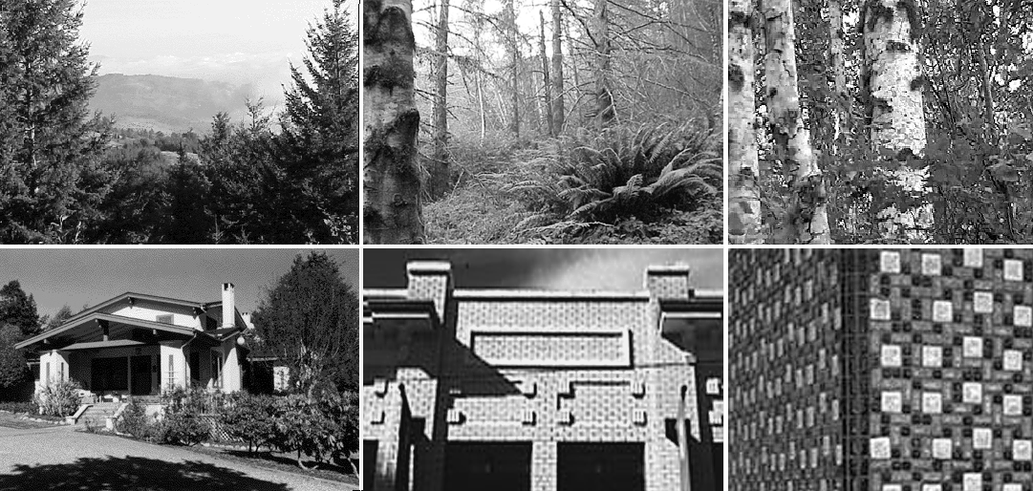
Figure 2. Categories shown in photos: Top: Site vistas, elements & textures, Bottom: Architectural forms, elements & materials

Context: designers, duration, site type, objectives
In each case, architecture students in a first professional degree program with basic Web authoring training, collected information at their studio project sites for a few hours and then summarised the information over a week or two.
In the first group, 30 students visited a natural undeveloped hillside to find and record the site for their upcoming studio project. In the second group, 21 first year graduate students in a computer graphics class visited their studio sites, individually or in small groups. Only those in the same design studio designing for an empty lot were included in the study. For comparison, we also looked at a third group, 85 second year undergraduates, who had gone together to an urban site with specific issues to address and a fourth non-digital group who created printed rather than online reports.
The first group generated 10 pages with photos (average 2.9 photos) and 8 pages with sketches (average 5.0 sketches) and one edited video. The second group created 21 pages with photos (average 2.4 photos), 2 pages with sketches and photos (average 3.5 images). The third studio group, working in groups of about seven students, created 18 more elaborate reports (average 7.7 images). The fourth group created 5 pages with sketches (average 2.6 images) and 6 pages with photos (average 7.0 images).

Data: what did the tools capture?
In the first group, compared to the sketchers, the photographers concentrated on more natural elements (86% to 68%). This could have been due to the fact that groups gathered and rested close to built structures, allowing time for sketching. For this case, both groups concentrated on either the very large scale or on very small scale (primarily natural textures). At the middle scale, both groups registered few examples of natural elements (one case or 3%) compared to architectural elements (8%). The designers saw natural elements as a part of a larger whole, whereas perhaps due to their training, they recognised architectural elements as having a more pronounced character worthy of highlighting.
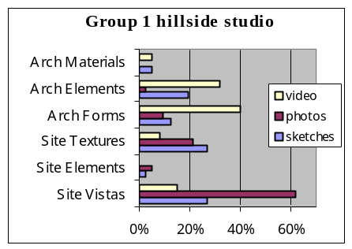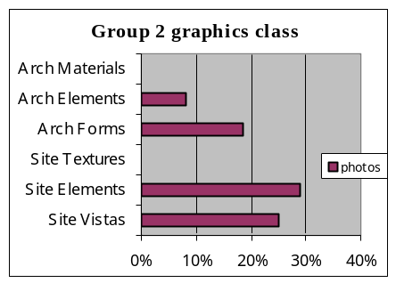
Figure 3. Image tally by media for groups 1 & 2
Students in the second group opted to use digital cameras over scanning sketches perhaps because it was faster and the class had a digital agenda. They concentrated on site elements (29%), and vistas (25%) with less attention to complete building forms (19%) architectural elements (8%).
Because of the third group’s agenda to look at urban continuity, they recorded large-scale information (80% of sketches and 82% of photos) much more frequently than medium or small-scale information. In comparing use of photos vs. use of sketches, students used photos much more than sketches for the large-scale site vistas, especially when they contained natural elements. Sketches, by contrast, were used for building scale pieces, with some drawn from photographs. Students found it easier to draw the regular geometric order of man-made forms rather than the complex chaos found in nature.
The fourth group went to a site that was primarily natural with adjacent buildings primarily on one side. This was reflected in the dominance of the site images (88% of the photos & 85% of the sketches) over architectural images. As with the other groups, photographs were used more than drawings for site vistas and drawings were used more for identifiable objects (site elements and architectural elements).
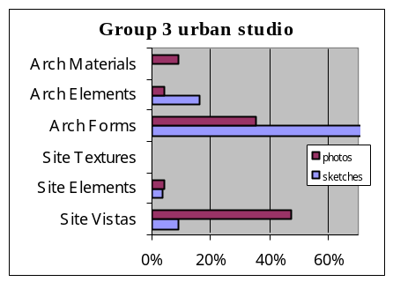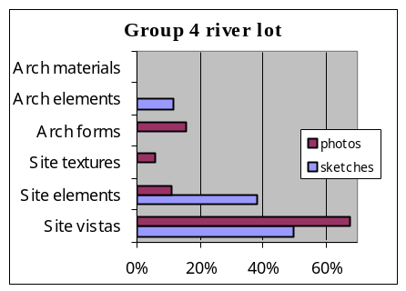
Figure 4. Image tally by media for groups 3 & 4

Qualitative aspects of the Group 1 video
Video from the first studio group visit was consolidated into a single tape. So while it is statistically insignificant, the video was logged to try a comparison method. Segments of the video were labelled with one of the six scale and content categories, and according to the duration of each segment, a percentage was assigned to each category. This procedure made it possible to compare video to the photos. The video’s anomalous emphasis on architecture over nature (72% vs. 18%) reflected that its ability to work better than film cameras under low-light interior conditions.
Reviewing the video produced the following qualitative observations. It gave a very vivid sense of capturing an ephemeral moment because of it arbitrarily captured people in specific activities with bits of particular conversations. The imperfect shaky camera and occasional voice-overs gave a stronger presence to the author than still images. Spatial adjacencies and rough orientation came through, but absolute relationships were difficult to perceive.

Discussion: What did we learn?
In looking at all the groups together, there is not a clear correlation between the recording medium and tallied report image categories. Within the wide variation of media use between groups, we observed a few tendencies. The students used photography for subjects too complex to draw, such as urban panoramas and organic textures. In all media, they highlighted things they knew well, such as architectural elements, and let less interesting pieces fall into larger views. They displayed both assigned information, such as building facades, and their own choice of engaging details. To generalize, people capture a subset of what is at a location depending on what they are looking for and their ability to find and recognize it. Individuals will do different things with tools depending on their training, talent, and interests.
The study revealed the role of influencing factors in place recording and the study of place recording. Among the many variables in the site recording process, the subject’s intentions and the character of the site appeared to be the most critical factors in defining what is collected. The type of tools and students training followed in importance. So to understand media variation, it is crucial to hold send all subjects to the same sites with the same directions.

Media Constraints & new tools
Observing and trying place-recording methods accentuated how each medium engages the user to tailor work to its nature. The tools invite us to make an appealing artefact and control how this can be done. “Every type of visual, numerical, and verbal representation follows its own logic, "talking back" to the designer and clouding the relationship between representation and reality." (Bosselman 2000) Creating a pleasing composition becomes as important as recording important information. Circumstantial details like fleeting sunshine can make secondary forms inviting. Conversely, some subjects do not fit some techniques. Silence on audiotape or stillness in video compels us to create drama or motion, vast repetitive fields challenge sketch artists.
While each tool frames its results, simpler tools tend to be more versatile and high-tech tools more constrained. Sketchbooks can carry representational images, analytic diagrams, and text in idiosyncratic ways, but their digital equivalents such as personal digital assistants, constrain input techniques more narrowly. As new tools are precisely tuned to specific tasks, tool selection becomes more critical. Just as tight interiors require a wide-angle lens, situations can demand specific kinds of tools.
The specialization of each medium means that resulting products cannot be parsed in the same way for analysis. The nature of a tool’s raw data and its manipulation must be considered in guiding the site recording process and in characterizing the resulting products. Perspective images are more naturally categorized according to pictorial aspects, such as viewpoint distance, than by logocentric content categories. Sentences can be sorted into abstract content categories (spatial, cultural, natural, cultural) more easily than images since text articulates conceptual thinking more clearly than graphics. Examining additional place videotapes (Kellett & Girling 2000) confirmed that a measurement’s usefulness is dependent on the medium. While it was possible to translate the image tally to video time segments, tallying viewpoint distance became less interesting after the cameraperson standardised shots to fixed-location zooming and panning to reduce camera shakiness.

FUTURE WORK: Methodical and artistic approaches
In this round, tallying web page imagery was more useful for revealing a group’s site recording interests than for showing tool bias. With modification, field report analysis could be more informative about the media’s influence on vision and perception. Comparing concrete factors such as the perceived dimension of represented vs. real objects could be more fruitful than the image tallies. Supplementing website analysis with interviews or thinking-aloud sessions would illuminate more of the process-process connections. (see Herbert 1993 & Robbins 1994) For new tools, the protocol could include using subjects to review the created material:
- Preparation: Make pilot trials with audio taped notes, train students in using tools.
- Field Visit: Design students visit a compelling place with different toolkits using audiotape annotation, then summarise findings for the Web
- Survey: Web authors are queried about site features to track site perceptions and memories.
- Review: Other students examine the Web reports; describe differences in how the presentations capture sense of place and scale, before and after visiting the site.
- Analysis: Web pages, surveys, audiotapes and student reviews are examined for robustness of place description and accuracy of scale depiction.

With the long-range goal of defining task-appropriate toolkits, this study begins to document how tools affect field recording and examines one way to look at Web-based site documentation. Related investigations include:
- Refining the methodology for studying site-recording,
- Comparative testing of recording tools
- Examining media’s role in successful site-specific designs
- Tracking representations in site perceptions during the design process
- Developing more robust representations.
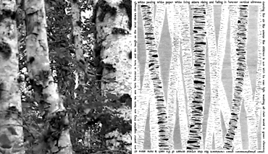
Figure 5. Media shapes what is captured: sketch shows abstract concept of alders
Both methodical research and creative exploration can contribute to our understanding of place representations. In a recent study on the representation of non-visual site information, Robitaille (2000) explored collage techniques to record sensations of touch, sounds and smells in an environment. This type of artistic approach can be appropriate because a designer needs not only factual information, but also details shaping the gestalt of a place. Randolph Hester, a landscape architect, described on-site sketching as “visual listening: looking so carefully that you pick up essential spatial details that create the uniqueness of a site…. Active meditation reveals the essence of a place, the soul that touches your heart the way that office drawing cannot.” (1993) The ephemeral moment of long diagonal shadows or a squirrel jumping across a frame can strike a chord and bring the designer back to that moment of being there. Part of the job of understanding a site is becoming aware and open enough to see the unexpected, to relish the moment of just experiencing what happens.
So a balance needs to be struck between rational procedures and intuitive gathering. Checklists of site information topics (White 1983) can make examinations more comprehensive, but may constrain observations to those expected from traditional tools. Too tight a recording protocol would make it difficult to pick up serendipitous events that stimulate design. Rather than defining what should be found, we should concentrate on defining procedures for searching. In this way, we can guide site surveys to be comprehensive and efficient while fostering the circumstantial perceptions that can spur design thinking. Reviewing the student websites showed that we see what we look for and we see what we can name. Our challenge is to open our eyes to what we’re not looking for.

Acknowledgements
Katalin Czege, Ronald Kellett, G.Z. Brown and Stephen Lamb helped shape and encourage the ideas in this paper. The University of Oregon Foundation and the Intel Corporation provided support for this enquiry.

References
Bosselman, Peter, 1998, Representation of Places, Univ of California Press, Berkeley, p. 187
Corner, J., 1992, “Representation and landscape: drawing and making in the landscape medium”, in Word and Image, 8(3), p. 243-275.
Crowe, N. and P. Laseau, 1984, Visual Notes, Wiley & Sons, New York
Debevec, Paul, http://graphics3.isi.edu/~debevec/
Digital Michaelangelo, http://graphics.stanford.edu/projects/mich/
Downing, Frances, 2000, Remembrance and The Design of Place, Texas A&M Press, College Station, TX.
Ehrhardt, M. and M. Gross, 2000, “Place Based Web Resources for Historic Buildings”, ECAADE 2000, pp. 177-179
Herbert, D., 1993, Architectural Study Drawings, VNR, New York.
Hester, R., 1993, in “Portfolios [drawings of landscape architects]”, in Landscape Architecture, May 1993, 83(5), p. 57-63.
Hiss, T., 1990, The Experience of Place, Knopf, New York
Kellett, R. and Girling, C, 2000, Elements of Neighborhood CD-ROM, Eugene, OR
Lynch, K., 1972, What Time is this Place?, MIT Press, Cambridge
Robbins, E., Why Architects Draw, MIT Press, Cambridge, MA.
Robitaille, Sophie, 2000, Make Sense, unpublished M.L.A. thesis, University of Oregon
White, E. T., 1983, Site Analysis, Architectural Media, Ltd., Tallahassee, FL.

